Comments on this link:
Supply Chain Intel Hub

Materials & Disciplines
- In the “All Materials” filter, it seems it is not reading all the materials. There are 30 materials registered.
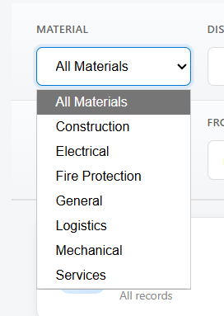

- In the “All Disciplines”, I think it is reading again from the material, whereas it should be reading from material code.
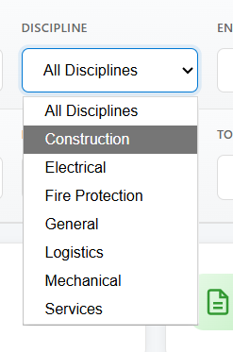

- In the “All Entities” filter, it seems it is not the same list as entities in the Supplier Marketplace tab, as it is reading 20 entities here but in the supplier marketplace it is reading 19. What is the entity “CENTRICO”? and what is “Unknown”?
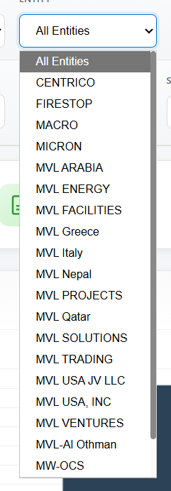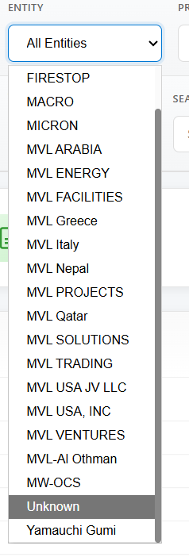

- In the field “All Suppliers”, currently it seems all suppliers are appearing. However, if I filter by Supplier, it seems that the supplier Profile is not working.
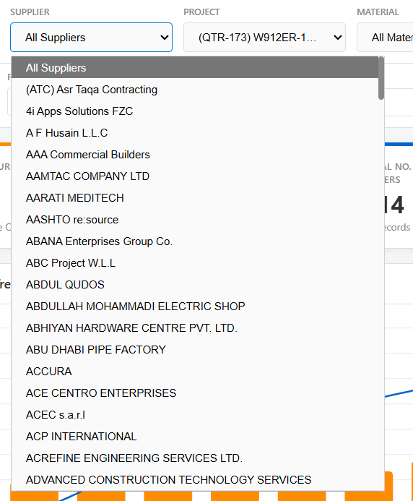

- A clear button should be added to clear any filters at any point in time.

- I do not think the search button is working as it is not giving any filtering or any result. When I use the search filter, it should give me some options as to what it is searching for.

I do not think this ribbon is reading all the data correctly. There are 30 materials, 13 disciplines, and here the total material spend should match with the values in the supplier marketplace and the global spend analysis value. I am not sure also what is the % in green under the spend called “% utilised”? In the last tab of active projects, also the number of suppliers is much more than that, this is why I think this page is not reading the entire data.

- Total Spend by Discipline: Here can we replace Actual by “Ordered”. Also we have 13 disciplines here and not 7 disciplines only. I think the code is not ready correctly the data.
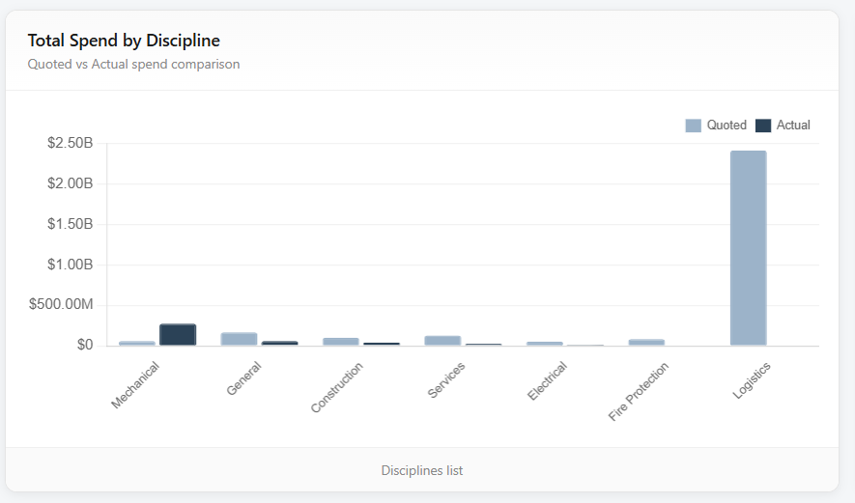

- Material Distribution: There are more than these materials (30 nos). Also this pie chart should be interactive to be able to filter through it.
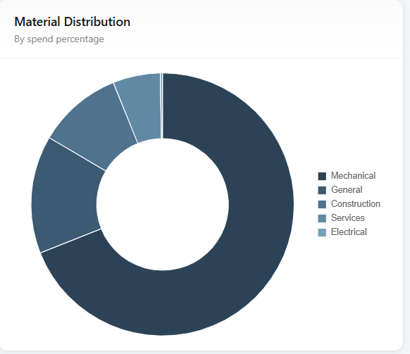

- Supplier Profile is not working. Also the rating can it be with stars?
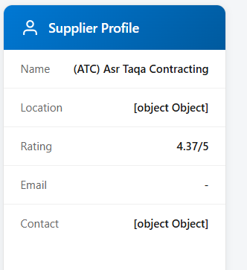

- Supplier Overview: This list should display all the suppliers and it gets filtered when we filter from the top.
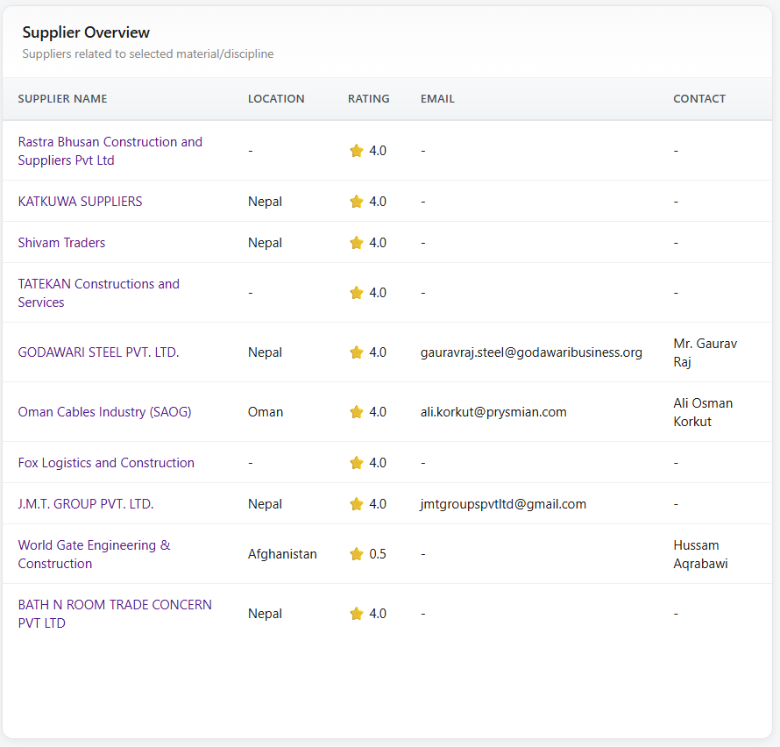

- Approved Material: from where this is reading? Currently we do not have this list but we are working on creating it.
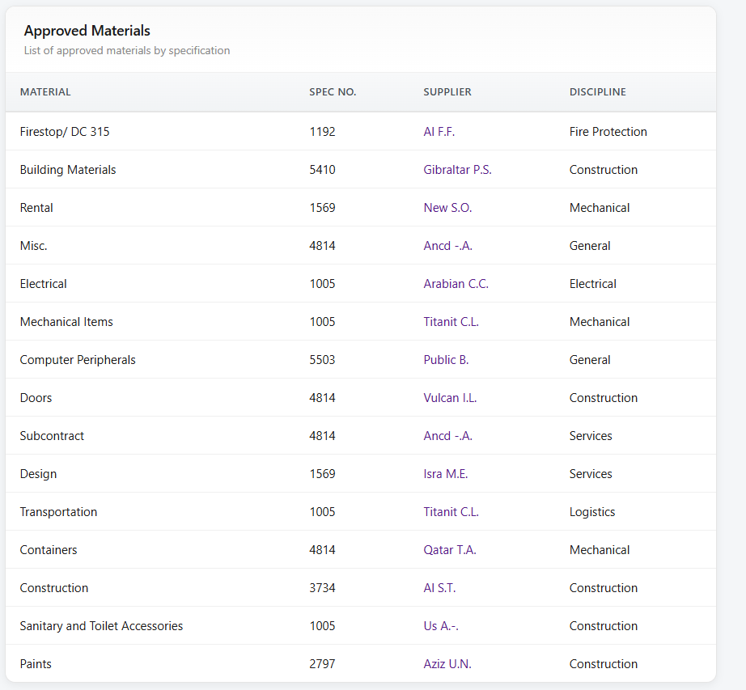

- PO Material is not changing when we filter on the top.
